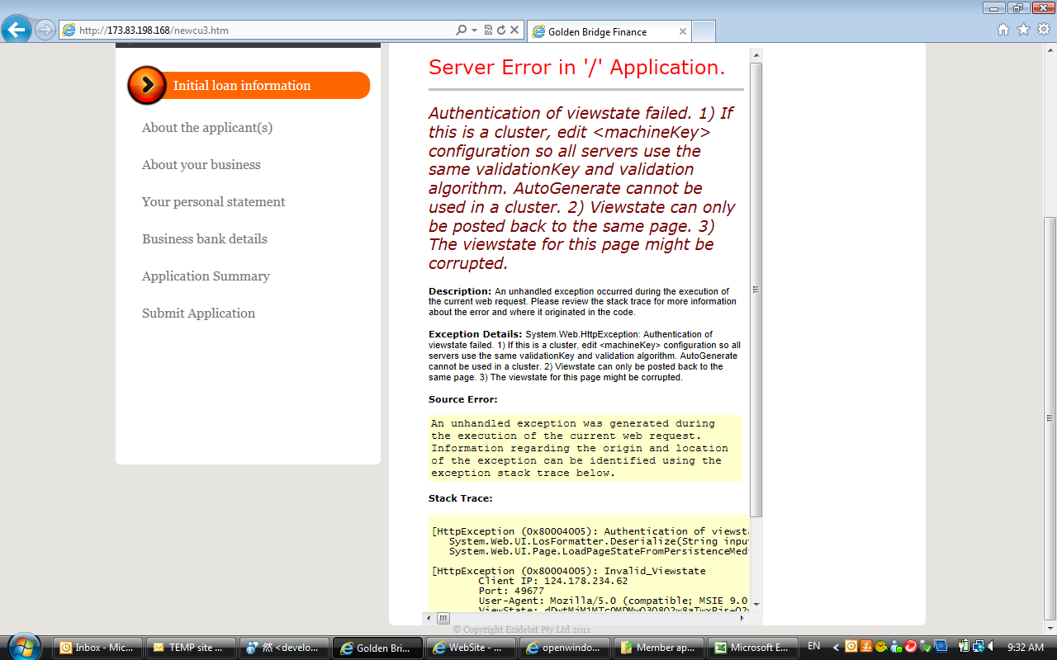

- Pre-qualification
- Apply now
- About yourself
- About your work
- Your bank details
- Submit application

